COMSATS UNIVERSITY ISLAMABAD, LAHORE CAMPUS



ASSIGNMENT

NAME : | HARIS ALI
ROLL NO : | FA24-BBA-068
INSTRUCTOR : | MA’AM MUFEEZA MANZOOR
COURSE : | PROGRAMMING

PROGRAM 1 :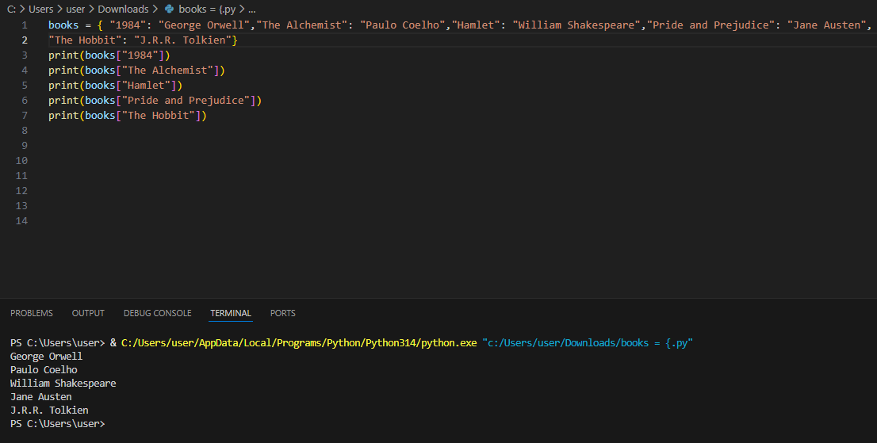
PROGRAM 2 :
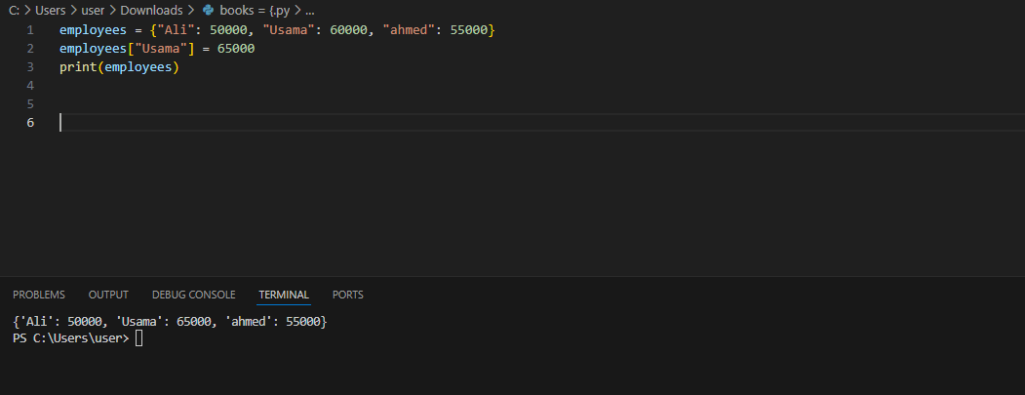
PROGRAM 3 :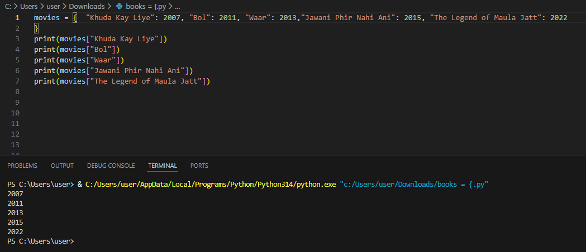
PROGRAM 4 :
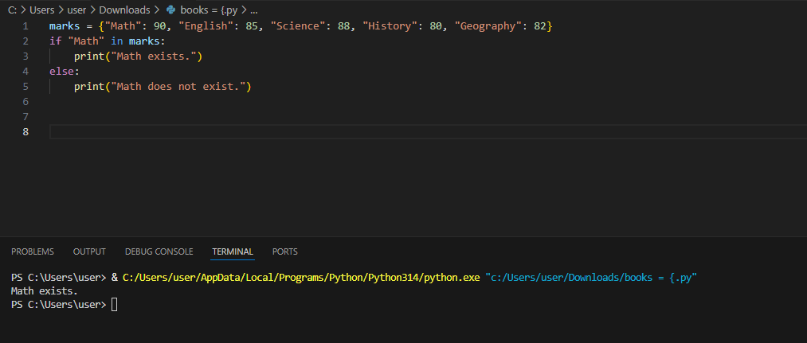
PROGRAM 5 :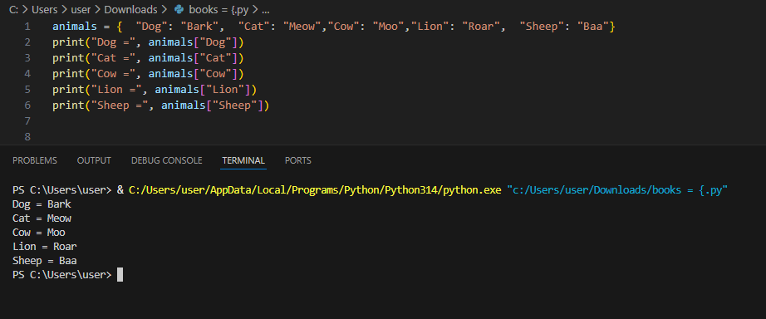
PROGRAM 6 :
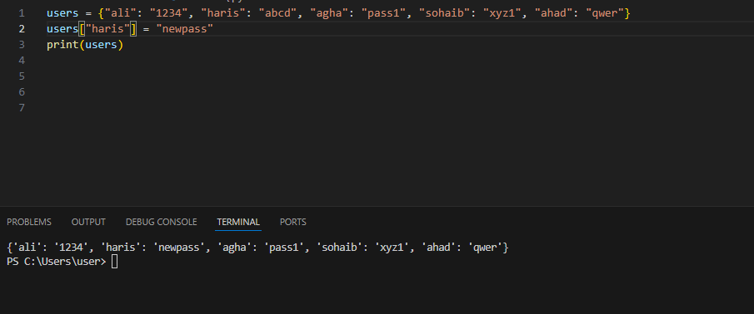
PROGRAM 7 :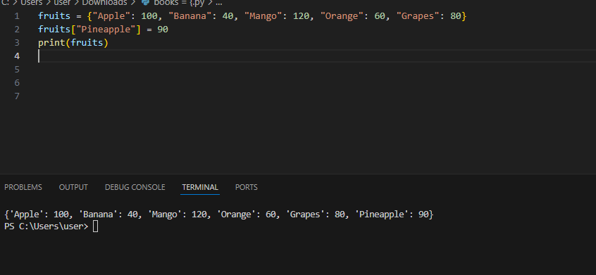
PROGRAM 8 :
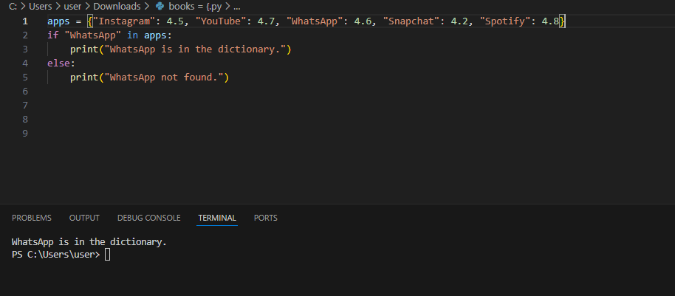
PROGRAM 9 :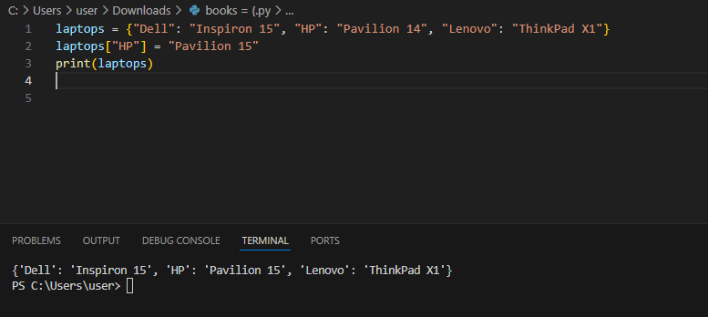
PROGRAM 10 :
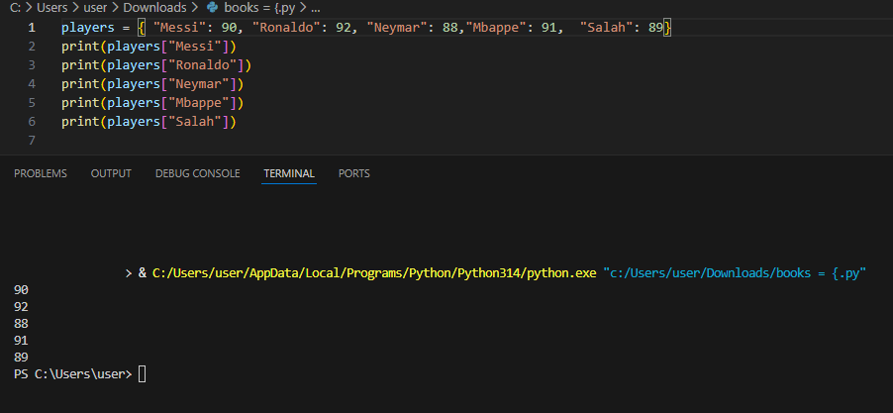
PROGRAM 11 :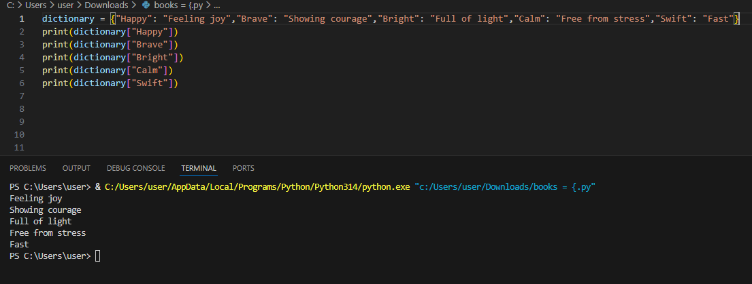
PROGRAM 12 :
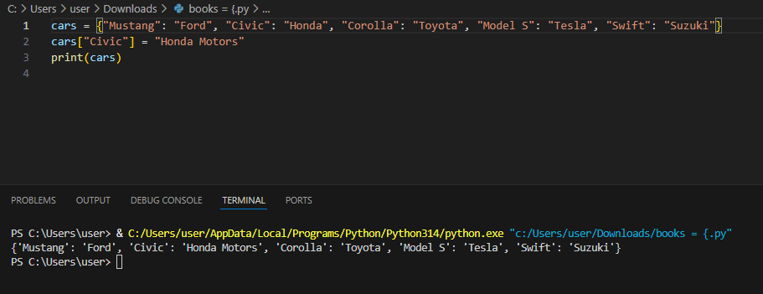
PROGRAM 13 :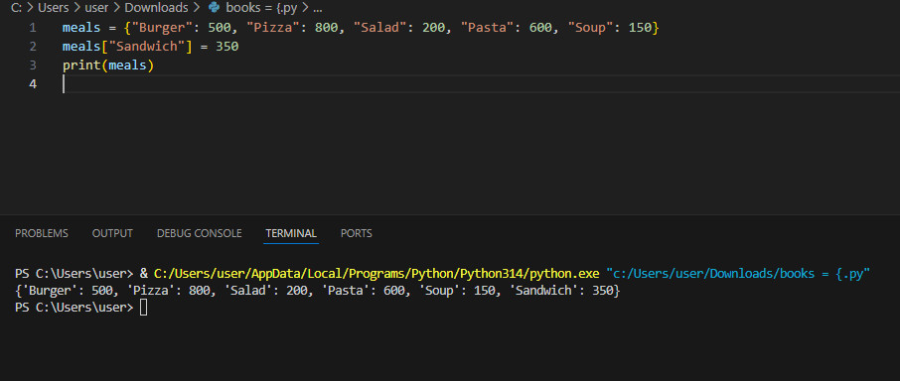
PROGRAM 14 :
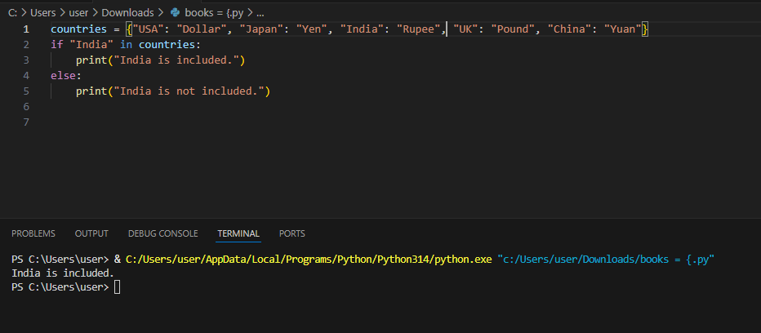
PROGRAM 15 :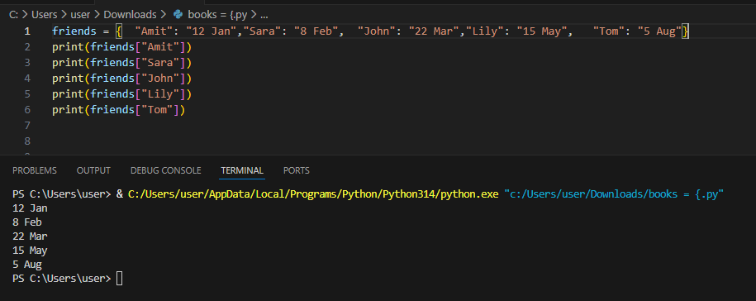
PROGRAM 16 :
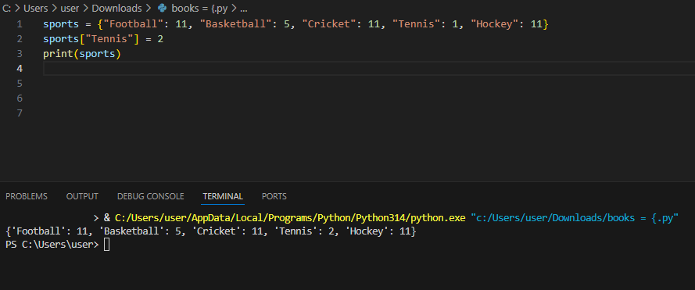
PROGRAM 17 :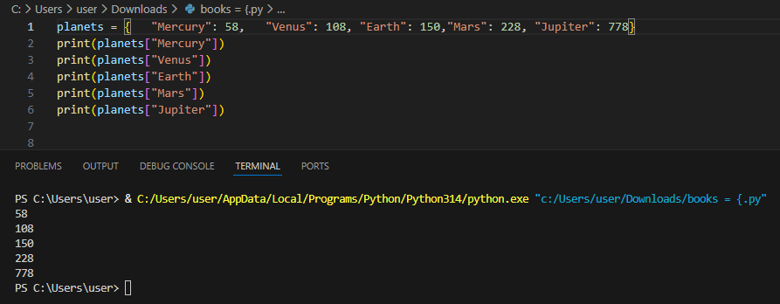
PROGRAM 18 :
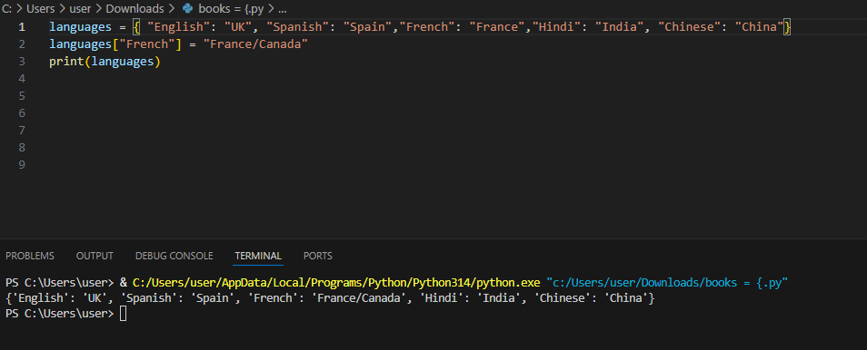
PROGRAM 19 :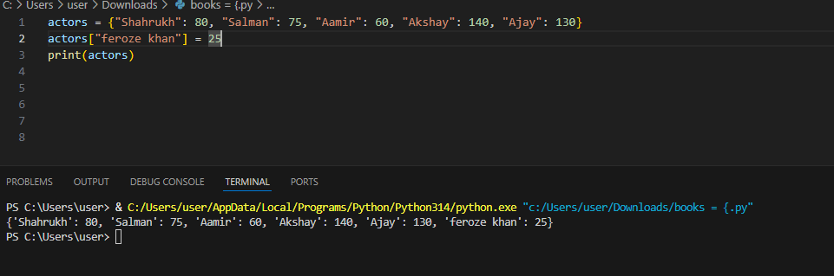
PROGRAM 20 :
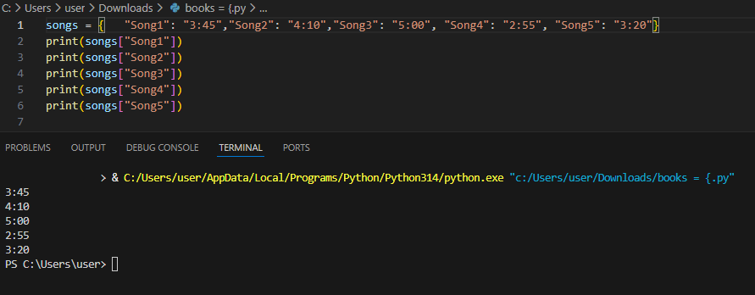
PROGRAM 21 :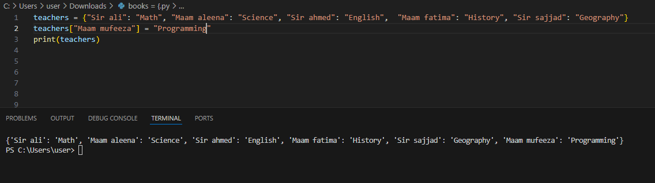 PROGRAM 22 :